|  |  |
| --- | --- |
|  | Program Doktor Program Studi Teknik Geomatika  Departemen Teknik Geodesi  Program Pascasarjana Fakultas Teknik Universitas Gadjah Mada |

**Form Penilaian Kelayakan Naskah Disertasi**

|  |  |  |
| --- | --- | --- |
| **Nama** | : | {Nama} |
| **NIM** | : | {NIM} |
| **Judul Disertasi** | : | {JudulDisertasi} |
| **Pelaksanaan Ujian** | : | {Tanggal} |
| **Tahapan** | : | Penilaian Kelayakan Disertasi Mahasiswa Doktor |

|  |  |  |
| --- | --- | --- |
| **No** | **Kriteria Penilaian** | **Nilai** |
| 1 | Materi Naskah Disertasi (Kebaruan, Orisinalitas Temuan dan dan signifikansi kontribusi) (CPMK 1/ CPL a, b) | {Skor1} |
| 2 | Kemampuan penalaran (CPMK 2/ CPL d) | {Skor2} |
| 3 | Metode Penelitian (CPMK 3/ CPL e, f) | {Skor3} |
| 4 | Tata Tulis Naskah Disertasi (CPMK 4/ CPL g) | {Skor4} |
| 5 | Konsistensi Uraian Naskah Disertasi (CPMK 4/ CPL g) | {Skor5} |
| **Rata-rata** | | **{Rata}** |

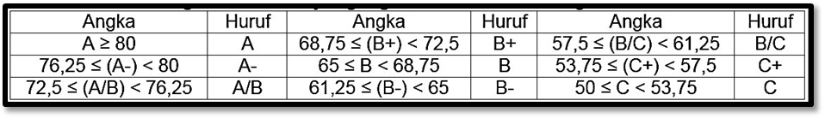

|  |  |
| --- | --- |
|  | Yogyakarta, {Tanggal} |
|  | Penguji, |
|  |  |
|  | {NamaDosen} |